* Salary for an employee to be increased or decreased by percentage

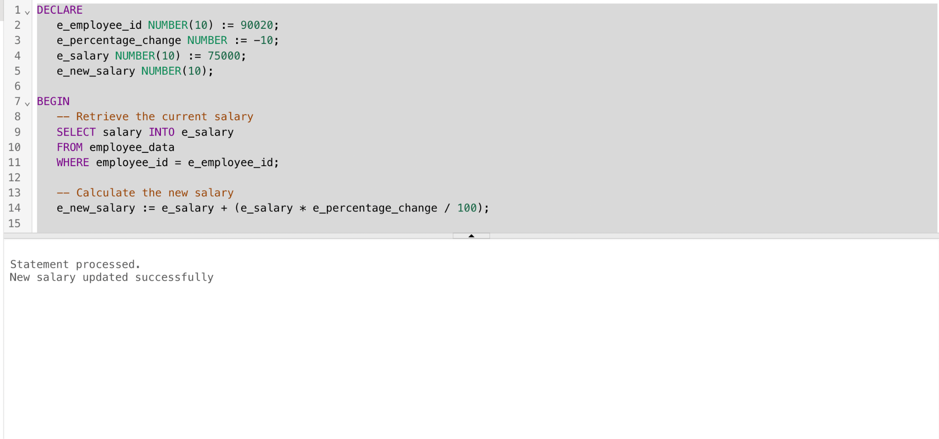

* Here I’am decrease the salary (75000) of employee ‘90020’ by 10%

